**Tutorial 3: Physical Layer (OSI Model)**

**Q1**

(a) With reference to the diagram, describe **encapsulation** process from source node to destination node. (8 marks)

* The user data is segmented by the transport layer, placed into packets by the network layer, and further encapsulated as frames by the data link layer.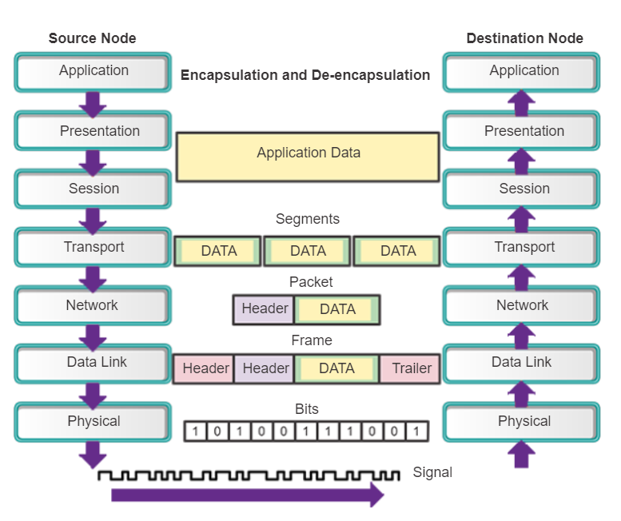
* The physical layer encodes the frames and creates the electrical, optical, or radio wave signals that represent the bits in each frame.
* These signals are then sent on the media one at a time.
* The destination node physical layer retrieves these individual signals from the media, restores them to their bit representations, and passes the bits up to the data link layer as a complete frame.

(b) The physical layer standards address three functional areas which are **physical components**,

**encoding** and **signalling**. Discuss each of the functional areas. (6 marks)

**Physical components**

The physical components are the electronic hardware devices, media, and other connectors that transmit and carry the signals to represent the bits.

**Encoding**

Encoding or line encoding is a method of converting a stream of data bits into a predefined "code”. Codes are groupings of bits used to provide a predictable pattern that can be recognized by both the sender and the receiver. In the case of networking, encoding is a pattern of voltage or current used to represent bits (the 0s and 1s).

**Signalling**

The physical layer must generate the electrical, optical, or wireless signals that represent the "1" and "0" on the media. The method of representing the bits is called the signaling method.

**Q2**

(a) Identify the type of the **copper cable** and briefly describe the cable. (9 marks)

| **Cable Image** | **Cable Type** | **Description** |
| --- | --- | --- |
|  | **Unshielded twisted pair** | * Consists of four pairs of color-coded wires that have been twisted together and then encased in a flexible plastic sheath(outer jacket) that protects copper wire from physical damage. The twisting of wires helps protect against signal from interference. |
|  | **Shielded twisted pair** | * Similar to UTP but contains an extra braided shield to help shield the cable signals from interference. * STP cables combine the techniques of shielding to counter EMI and RFI, and wire twisting to counter crosstalk. |
|  | **Coaxial cable** | * Coaxial cable has a single copper conductor at its center. A plastic insulator provides insulation between the copper conductor and the braided copper shielding. The copper shield helps to block interference. |

(b) Discuss the application of each of the following **UTP cable types**. (6 marks)

| **Cable Type** | **Cable Use / Applications** |
| --- | --- |
| Straight-through cable | Cable that used to interconnect devices in different categories.   * Switch to router * Switch to pc/server * Hub to pc/server |
| Crossover cable | Cable that used to interconnect similar devices in same categories   * Switch to switch * Hub to hub * Router to router * Pc to pc(NIC to NIC) * Router to pc * Switch to hub |
| Rollover cable  (also known as “Cisco” cable) | Connect a computer terminal to a router’s/switch’s console port |

(c) When is a wired connection **preferred** to a **wireless connection** by an end-user device? (8 marks)

**Reliability and stability**

Wired connections are generally more stable and reliable as their signal would not be influenced by other connections. To illustrate, if there are more than one wireless connections that are close to each other, one signal might interfere with another which can compromise stability.

**Security**

A wired connection is well protected from unauthorized access when configured with security applications such as firewalls. Moreover, packet transmission through wired connection would be easily be intercepted

**Speed**

Wired connection is generally faster than wireless connection. This is because it never weighed down by unexpected or unnecessary traffic. Any unauthorized user is prohibited to connect to the network unless their device is connected using Ethernet cable.

**Direct data transfer**

Wired connections offer a direct connection to data transfer compared to wireless connections which require an intermediary device to broadcast wireless signals. Therefore, wired connections are faster.